We are: confident, respectful and positive.
WE ARE FAMILY!

Meet the teacher

Farwell Junior High August 16,2016

In this issue:
• About Me
• What to expect this year?

About Me
My name is Kenzi Green. I am the 7th and 8th ELAR teacher. This is my first year here at Farwell Junior High.
I previously taught Junior High in Lubbock at Sharp Academy (ADD, ADHD and Dyslexia school), and I also taught 4th grade in Seagraves, TX. Before I became a teacher I was in the dental field for 10 years.
My husband owns his own hail and crop insurance company. We have a daughter that will be in 4th grade and a son that will be in Kindergarten.
We are excited to be part of the Farwell school and community.

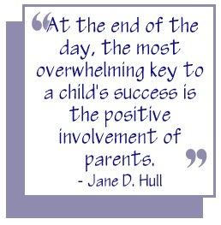

What to expect this year?
I am big on parent/teacher communication. I will be communicating with you guys on a regular basis this year. I know many of you work so you can expect communications in forms of: monthly online newsletters (which is located on the teacher webpage), teacher webpage, notes, e-mails, texts, phone calls, and face to face meetings. I truly believe that if we have communication with each other, the students will strive for success.
I look forward to a great year with not only your child but with you!
Sincerely,
Kenzi Green
kgreen@farwellschools.org

[Cite your source here.]

